RiPower from Rittal
Rittal and Eplan at the SPS 2024
12 to 14 November in Nuremberg
Halle 3C, Booth 321
Greater planning convenience with the switchgear configurator
Herborn, 2024-11-11
Networked ecosystems offer a vast range of opportunities in plant engineering. This is precisely where Rittal’s new RiPower planning tool comes in: thanks to simplified workflows, the configurator accelerates the safe planning and construction of low-voltage switchgear and speeds up collaboration on a cloud platform. Planning experts and switchgear manufacturers receive straightforward support when planning their systems, with a direct digital link to the established products and software solutions from Rittal and Eplan.
Customers demand speedy project execution, though they also need planning security, cost transparency, and efficiency. This means there is hardly any time to spend reading time-consuming manuals for each switchgear component, which are used to manually plan the installation in the enclosure or generate parts lists by hand. These are not trivial tasks for planning specialists and plant constructors. Rittal has recognised this and offers the new RiPower configurator – the successor to Power Engineering – a simple tool with which users can not only plan their system quickly and easily, but also achieve the greatest possible planning comfort thanks to the seamless data consistency with Rittal and Eplan software solutions. This makes it much simpler to manage power distribution systems and busbar components.
User-friendliness in a familiar environment
RiPower is easy to operate and user-friendly. With one mouse click, users can choose the RiPower configurator from various apps with the same design, such as the Eplan Data Portal, eStock or RiTherm. The planning tool not only enables the configuration of Ri4Power energy distribution systems but also of the new RiLineX and RiLine systems. RiPower automatically generates the interior installation of a switchgear product through intelligent system queries. Consequently, this work no longer has to be done by a specialist planner – the system’s power output limits are automatically taken into consideration. Standard-compliant systems guarantee the protection of persons and systems; incorrect planning is impossible with RiPower. Users benefit from the software’s automatic documentation and creation of design verifications as per IEC 61439; they can create their own design verifications using a customised design verification wizard.

Transparency even after configuration
Once the configuration is complete, RiPower generates field-specific assembly instructions that permit rapid and standard-compliant installation. The system can be pre-assembled upon request at the Rittal Application Center in Gera. Besides downloading the relevant documents, users can order the components directly from the Rittal online shop at the touch of a button or obtain a detailed offer. RiPower fits seamlessly into the existing Rittal and Eplan ecosystem: Data from the configurator, such as parts lists, can be further processed in Eplan P8 or AutoCAD, and the machine tools from the Rittal Automation System can also be connected for machining copper.

With RiPower, Rittal addresses the challenges in the industry and the energy sector: Faster project management, simple configuration, transparent pricing, and more comfortable planning are the keys to efficient switchgear construction and, thus, essential modules in achieving the energy transition quickly.

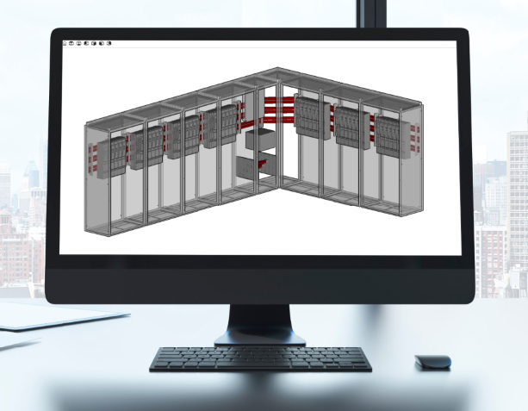
Caption  Thanks to simplified workflows, the configurator RiPower from Rittal accelerates the safe planning and construction of low-voltage switchgear and speeds up collaboration on a cloud platform. |  | .

Rittal

Rittal is a leading global supplier of enclosure systems, automation and infrastructure with its industrial, IT, energy and power, cooling and service units. Rittal products and solutions are used in over 90% of global industries – standardised, customised, and always of the very best quality.
Our approach and methodology: With their combined hardware and software expertise, Rittal, Rittal Software Systems (Eplan and Cideon) and Rittal Automation Systems (RAS, Ehrt, Alfra) optimize, digitize and automate processes along the entire customer value chain, including the IT infrastructure – from panel building and switchgear manufacturing to mechanical engineering, factory operators and the energy sector.
Our delivery promise: Rittal standard products are delivered in Germany within 24 hours, and within 48 hours throughout Europe.
Customer focus
Improving efficiency and increasing productivity through automation and digitalisation is one of the biggest challenges for our customers. This requires in-depth knowledge and expertise, the combination of hardware and software, and cross-sector networking. We are convinced that creating and connecting data rooms is crucial to the success of industrial transformation. And that is exactly our speciality and field of competence.
Eplan and Rittal are driving the development of the digital automation twin, making data accessible and useable in operations as well. Cideon is improving data consistency in the digital product twin context with its CAD/CAM, PDM/PLM and product configuration expertise.
Sustainability
Environmental and climate protection, social commitment and ethical corporate management are a given for Rittal. We take our responsibility for a sustainable future seriously. Our approach to resource management and conservation involves continuous improvement of our own production processes and ensuring that our products have the lowest possible Product Carbon Footprint. Our solutions support our customers in achieving their own climate targets.
Family business and global player
Founded in 1961, Rittal is the largest company in the owner-operated Friedhelm Loh Group. The group operates worldwide, with 12 production sites and 95 international subsidiaries. It has 12,100 employees and posted revenues of 3 billion euros in fiscal 2023. In 2023, the Friedhelm Loh Group was presented with the “Best Place to Learn” and “Employer of the Future” awards. In 2024, Rittal was awarded the Top 100 Seal as one of Germany’s most innovative medium-sized companies for the third time in a row.
For more information, visit www.rittal.com and www.friedhelm-loh-group.com.

Corporate Communications
Dr. Carola Hilbrand Rittal GmbH & Co. KG
Corporate & Brand Communications Auf dem Stützelberg
Phone: 02772/505-2527 35745 Herborn
hilbrand.c@rittal.de www.rittal.com


Follow us:

